Research Project
Real-time Simulation and Processing of Peripheral Nerve Spike Activity

David Wallace Croft
david@CroftSoft.com

Research Advisor
Lawrence J. Cauller, Ph.D.

2005-12-22

Cognition and Neuroscience Doctoral Program
School of Behavioral and Brain Sciences
University of Texas at Dallas

Abstract
As a first year research project, the student developed the software to simulate and process peripheral nerve spiking activity. The software was designed to meet the requirements of a peripheral nerve interface for the control of artificial arms and hands. To demonstrate the real-time capabilities of the software, the simulation generated realistic spike data based on user input from a joystick which was processed to direct the two-dimensional movement of an animated virtual limb (or finger).

Introduction
In 1982, Georgopoulos and his colleagues (see Krakauer 2000) first demonstrated the correlation between the direction of arm movements and the simultaneously recorded spiking activity in the primary motor cortex (MI) of monkeys. Chapin and his colleagues (Chapin 1999) built upon this discovery by demonstrating that spike signals recorded simultaneously from many MI neurons in rats could be processed in real-time such that rats could directly move a robotic arm using brain activity alone. Several investigators have subsequently demonstrated the feasibility of using MI cortical brain activity for the real-time control robotic arms or computer cursors moving in three dimensions in monkeys (Taylor 2002, 2003; Tillery 2003) and even human subjects.
As a member of the Laboratory for Cortical Neurointeractivity headed by Dr. Lawrence J. Cauller, the student is interested in the long-term objective of contributing to research related to the recently awarded grant “Neuro-micro-Transponders: Wireless Neural Control of Artificial Arms and Hands”. This research differs from previous efforts in that spike activity from peripheral nerves, rather than intracranial cortical neurons, will be used as the input to the control system. The ultimate objective is to enable amputees to control prosthetic arms and hands using signals from the peripheral nerves that remain in the stumps of amputated arms. By all accounts, a peripheral control system is far more medically acceptable than the intracranial systems described above and may even provide a superior neuroprosthesis for spinal cord patients, the major application proposed for the intracranial systems. If it becomes possible to obtain these peripheral neural control signals without damaging the nerves, additional applications abound, including physical enhancement or human/robot integration.
While the use of peripheral nerve may be more medically acceptable, this new technology faces significant challenges before peripheral nerve signals may be harnessed for such a control system. This project will tackle one of these challenges. Cortical brain signals correlate with high level features of movement related to the subject’s intention such as which way to move or which object to grasp. In contrast, peripheral nerve spikes are bottom level signals for the control of individual muscle units (which must be distinguished from sensory input signals – another challenge). This requires a new approach to the design of a control system which must transform the temporal sequence of spike impulses from a variety of fibers into a set of analog signals for the control of the actuators or motors that move the limb. In particular, spike signals from individual axons may lack the information content, or be too noisy for adequate limb control. This project addresses this problem with simulation software that transforms artificial spike signals generated under the control of a joystick into movement commands that control the position of a virtual limb. User control of the joystick in this simulation corresponds to the amputee’s intended movements, and the artificial spike signals correspond to those which would be transmitted through peripheral nerves in the amputated stump where they are detected and transformed into limb movements. By providing immediate feedback, the accuracy and responsiveness of the control system may be evaluated with respect to a range of spike signal properties (i.e. frequency limits, information content, noise). In addition, this project will provide a testing platform for alternative transform algorithms and may ultimately lead to a training simulator to prepare amputees for artificial limb control.

Methods
With design feedback from Dr. Cauller, the student programmed the desktop application “Newt Cyborg” to meet the requirements of the research project proposal. A screenshot of this program is shown in Figure 1. The reader may install and run the program via the webpage http://www.CroftSoft.com/library/software/newt/. The source code, written in the high performance cross-platform Java programming language, is available under the terms of the Open Source “Academic Free License version 2.1”.

Directions of Movement
Movement of a joint such as a finger requires the contraction of a muscle and the relaxation of its antagonist. Flexing a finger requires increased nerve activity to the flexor with a simultaneous decrease in the tonic firing rate on a separate nerve to the extensor. Extending the finger requires the reverse. For every type of movement and its reverse, at least two nerves are required.
The student simulated activity from four nerves so as to demonstrate flexion, extension, abduction, and adduction. Figure 1 shows four spike rasters scrolling across the screen. The windowed average firing frequency is displayed immediately beneath each raster, in this screenshot at 123, 17, 16, and 107 spikes per second. The smaller circle within the upper square is a cursor which represents the position of a fingertip and the larger circle represents the target. For each trial, the operator is required to move the cursor to the stationary target and hold it on target for three seconds. Once accomplished, a new trial is started by randomly relocating the target to another position within the upper square.

Real-Time Requirement
The earliest experiments in this area of research used offline batch processing. The student ensured that the software algorithms implemented in this project could determine the intended direction of movement from the spike activity in real-time. For this purpose, real-time was defined as a processing lag of less than 100 to 300 ms, depending on the estimated requirements for the subsequent neuroprosthetic research.

The first iteration of the software received input from a joystick for input. The Open Source “JInput” application programming interface (API) software library was integrated for this purpose. The rate at which the joystick controller could be polled using this API was recorded. The joystick is replaced by a “virtual joystick” operated by a mouse in the current implementation.

When the real-time mode option is enabled, the loop rate is constrained to a maximum of 200 loops per second. The actual loop rate achieved will vary from computer to computer. Every three seconds, the simulation measures and displays the actual loop rate achieved in the upper left area of the screen. In Figure 1, this is displayed as 195, indicating 195 loops per second.

To estimate of the number of nerve channels that could be processed simultaneously with the software, “Automatic” mode was enabled in which the operator input is simulated, the real-time option was disabled which removed to 200 loops per second constraint, and animation was disabled. The actual loop rate achieved was then recorded.

Plausible Parameters
The student used biologically plausible parameters in the generation of the simulated spike activity and the response of the virtual limb joint. The default parameter for the maximum firing rate of motor units is set to 120 Hz (Winter 2005, p207).

To represent the dependence of contractile force on muscle length (Winter 2005, p210), a linear force-length transform option is provided and enabled by default. This factor ranges from two at maximum muscle extension to zero at maximum muscle compression. When the cursor representing the fingertip is centered, the factor is one for both the agonistic and antagonistic muscles.

An additional option permits the operator to vary the joystick input to spike rate transform function. The functions available are the linear, exponential, cumulative distribution, logarithmic, and sigmoidal. These transforms can be refined by adjustable gain and offset parameters with default values of one and zero, respectively. The functions are shifted and scaled as necessary to map the joystick input range of -1 to +1 to the transform output range of 0 to 1 (Table 1). Note that the cumulative distribution function is equivalent to the exponential function with a negative gain (Figure 2).

Transform Function | Equation
Linear | (x+1)/2
Cumulative Distribution | [1-exp(-A*[(x+1)/2])]/[1-exp(-A)]
Exponential | [exp(A*[(x+1)/2])-1]/[exp(A)-1]
Table 1: Transform Functions (A ≡ gain)

When the simulation was running in “Automatic” mode, a simulated operator would control the cursor. This allowed the parameter space to be searched in faster than real-time. The strategy of the simulated operator was simply to move the joystick cursor in the direction that would move the fingertip cursor to the target. The simulated operator was given a reaction delay of 100 ms to study damping effects such as overshoot.

Performance Quantification
One test was to measure the time it took to move the cursor to a target and hold it on target for three seconds. Using the Open Source Apache Commons Math library, the software logged the task time for each trial plus the sample size, mean, standard deviation, and standard error for a series of trials where the parameters fixed.

Results
The reader is encouraged to verify the results by running the software under equivalent conditions as described in the following.

Directions of Movement
The software created by the student was able to accept input from a joystick or a virtual joystick, transform the input into a spiking rate, transform the spiking rate into a probability of firing for each of four motor neurons, and shift the position of the cursor in the four directions of movement appropriately with up, down, left, and right corresponding to flexion, extension, abduction, and adduction, respectively.

Real-Time Requirement
On the development computers tested, the simulation was able to loop at a rate of at least 120 loops per second which included polling the joystick controller or virtual joystick, updating the model, and animating the result. As the simulation was all within one process, the processing lag must have been less than the reciprocal of the loop rate, well under the 100 to 300 ms limit required.

When the simulation was allowed to run as fast as possible, it was able to achieve around 16,000 loops per second or higher on the development computer. Given that there were four neurons simulated in each loop, this suggests that the software could process the input from at least 64 nerve channels at a rate of 1000 Hz.

Plausible Parameters
As expected, the rate at which the cursor moves is proportional to setting of the maximum firing rate parameter, as observed subjectively.

When the force-length option is disabled, the operator must center the virtual joystick to stop the cursor from moving. At the center position, the firing rates of the opposing motor neurons are equal and the net muscle force is zero.

When the force-length option is enabled, the net muscle force is a function of both the firing rates to the opposing muscles plus the current muscle lengths. The result is that the net muscle force can be zero when the virtual joystick is at any position. When the joystick is moved away from the center, the cursor rapidly follows due to the difference in firing rates to the opposing muscles. Movement quickly slows and finally comes to a stop however, as the contractile force of the shortened muscle diminishes and the force of the lengthened muscle increases. The effect is that, when the force-length option is enabled, the joystick position in the input space maps to a cursor position in the target space.

Performance Quantification
For a given joystick input to spiking rate transform function, the student measured the mean time for the simulated operator to perform the task of moving the cursor to the target and holding it on target for three seconds. For the results shown in Table 2, the sample size is 10,000, the force-length option is enabled, and the offset is zero.

Transform Function | Gain | Mean (seconds) | Standard Deviation | Standard Error
Cumulative | 5 | 9.470 | 3.918 | 0.039
Cumulative | 1 | 10.718 | 3.994 | 0.040
Cumulative | 10 | 11.472 | 7.513 | 0.075
Linear | 1 | 12.273 | 4.962 | 0.050
Exponential | 1 | 14.748 | 6.636 | 0.066
Exponential | 5 | 45.280 | 30.278 | 0.303
Table 2: Mean Task Time

Discussion
In searching the parameter space during development and initial experimentation, it became apparent that the interesting question was centered around the tradeoff between minimizing the time to reach the target and preventing overshoot in order to stay on target. The results shown in Table 2 were selected for presentation as the most interesting out of several different experiments under a variety of conditions. As compared to the linear and exponential function transforms, the results show that the cumulative distribution function transform with a medium gain optimizes the tradeoff.

Function Comparison
This result contradicted the prediction by the student that the exponential function transform would minimize mean task time. The hypothesis was that the rapid increase in slope of the exponential function would permit the user to move the cursor to the target quickly and then, upon reaching the target, hold the cursor on target for the required three seconds by operating in the region below the “knee” of the exponential function where fine corrections could be made.

This was not the case, however, as controlling overshoot appears to be the dominant factor in minimizing total task time. At low gains, the exponential function performed worse than the cumulative distribution function. As the gain increased, performance deteriorated even further. From observation of the animation, it appears that as the gain increases, the simulated operator continually overshoots the target in a manner reminiscent of a chaotic orbit. One might imagine that a human operator would feel frustration in this circumstance.

One possible explanation for the superior performance of the cumulative distribution function transform is that its rapid onset permitted the operator to move the cursor to the target rapidly by making a large change to the input. When operating in the “flat” region, fine corrections to the input with small impacts to the output were then used to hold the cursor on target. As a result, the mean task time is smallest for the cumulative transform.

As the gain of the cumulative distribution function is increased, performance increases up to a point and then it decreases again. A higher gain results in a more accentuated transition between the low output “off” state and the high output “on” state. Once this gain becomes excessive, the simulated operator cannot flip between off and on fast enough to prevent overshoot given the 100 ms delay in reaction time.

This explanation of the superior performance of the cumulative distribution function is not entirely satisfactory, however, as it is just the mirror of the predicted advantage of the exponential function. There is no apparent reason why this should work when the “knee” of the function bends at another angle. It simply flips whether you are operating left or right of the knee during the two phases of the task, reaching the target and then staying on target.

Net Transform Output
The other problem with this explanation arises when you consider the interplay between the agonistic and antagonistic muscles. As the cursor moves away from center, the spike rate to one muscle is increased while the rate to its opposite is simultaneously decreased. Because the input was provided by one joystick instead of two, a two dimensional input space was used to control an output with four dimensions, the spike rate activity on the four nerves representing flexion, extension, abduction, and adduction. This reduction of two degrees of freedom was achieved by coupling the opposing muscles pairs as determined by the transform selected (Figures 3 and 4).

To use an analogy, consider an automobile with no brake and two foot pedal accelerators, one for forward and one for reverse. Further assume that the accelerators are coupled such that the operator does not have independent control; pressing down on one is the same as easing off on the other. How much one presses as the other eases is dependent on the selection of the coupling transform.

When you consider that the muscles in a pair directly oppose each other in moving the fingertip cursor, you can graph the effective net transform output by computing the difference (Figure 5). Surprisingly, for low gain values, the net transform is close to linear. At higher gain values, the net transform becomes less linear but one observes that the net transform output for the cumulative distribution function is exactly equal to that of the exponential function for the same gain.

This is no coincidence as the shifting and scaling of the functions were selected after some experimentation to achieve this effect. Here we see that even though the net transform output is exactly the same for both functions, the underlying choice of which function to use does make a difference in task performance.

When the net transform output increases from zero to one for the exponential function, the increase is largely due to an increase in the spike rate of one nerve while the spike rate of the paired opposing nerve remains low. In contrast, when the net transform output increases from zero to one when using the cumulative distribution function as the underlying transform, the activity on one nerve remains high while the activity on the paired opposing nerve drops rapidly. From observation of the animation of the spike rasters, it appears that overall spike rate is much lower for the exponential function in the mid-range; i.e., the cumulative distribution function transform operates at a higher tonicity.

Why should the overall tonicity make a difference, given that the net transform output is the same? It might be that the explanation lies in the probabilities of two nerves. Consider the four discrete possibilities during the small time interval in which a spike might occur: neither a spike on the nerve or its opposite occurs, a spike occurs on the nerve but not its opposite, a spike does not occur on the nerve but it does on its opposite, a spike occurs on both the nerve and its opposite. In the first and fourth case, there is no net movement. In the second case, there is forward movement. In the third case, there is reverse movement.

A mathematical analysis of the probabilities might explain the performance difference. It would be especially interesting to see how the probabilities of movement change as the number of nerves to each muscle increases. If the simulation were modified to allow for more than just four nerves, we might see the differences in performance between the exponential and cumulative distribution function transforms disappear.

Future Research
For the purpose of supporting future research towards a peripheral nerve interface for the control of artificial arms and hands, it is clear that a cumulative distribution function transform is a useful parameter, especially when you consider that it can be easily converted to an exponential function transform by changing the sign of the gain. Instead of applying the transform to joystick input to derive a spike rate output, it might be used to transform a spike rate input recorded from a biological peripheral nerve into the amount of force applied to the prosthetic joint. This might be analogous to the order of recruitment of motor units in biological muscles as the stimulation rate increases (Winter 2005, p205). Allowing a human operator to vary this parameter during training might prove to be a useful feature.
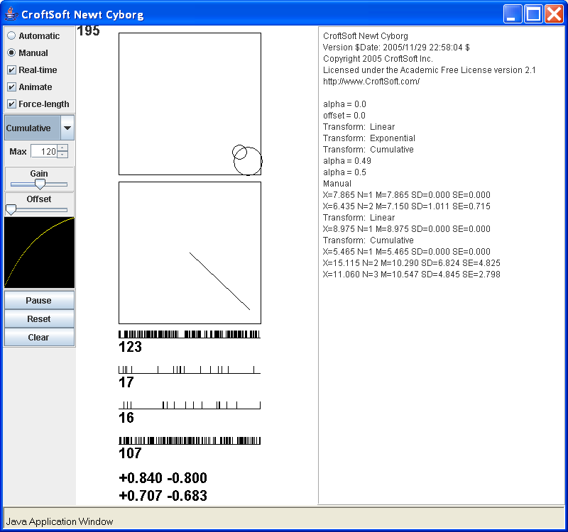
Figure 1: Screenshot of software
Figure 2: Cumulative Distribution, Linear, and Exponential Functions
Figure 3: Opposing Exponential Functions

Figure 4: Opposing Cumulative Distribution Functions
Figure 5: Net Transform

Bibliography
- Chapin JK, Moxon KA, Markowitz RS, Niolelis MA (1999) Real-time control of a robot arm using simultaneously recorded neurons in the motor cortex. Nat Neurosci 2(7):664-70.
- Krakauer JW, Ghez C (2000) Direction of Movement is Encoded by Populations of Cortical Neurons. In: Principles of Neural Science, 4th Ed. (Kandel ER, Schwartz JH, Jessell TM, ed), pp765-769. New York, NY: McGraw-Hill Medical.
- Taylor DM, Tillery SI, Schwartz AB (2002) Direct Cortical Control of 3D Neuroprosthetic Devices. Science 296(5574):1829-32.
- Taylor DM, Tillery SI, Schwartz AB (2003) Information Conveyed Through Brain-Control: Cursor Versus Robot. IEEE Trans Neural Syst Rehabil Eng 11(2):195-9.
- Tillery SI, Taylor DM, Schwartz AB (2003) The general utility of a neuroprosthetic device under direct cortical control. Proceedings of the Engineering in Medicine and Biology Society 25th Annual Meeting 2043-2046.
- Winter DA (2005) Biomechanics and Motor Control of Human Movement, 3rd Ed. Hoboken, NJ: John Wiley & Sons.

