Research Project Proposal
Correlating Direction of Movement with Spiking Activity

David Wallace Croft
david@croftsoft.com

2004-10-26

Research Advisor
Lawrence J. Cauller, Ph.D.

Cognition and Neuroscience
School of Behavioral and Brain Sciences
University of Texas at Dallas

Abstract
As a first year research project, the student will develop the algorithms and software to correlate the direction of limb movement with cortex spiking activity. Spiking activity will be simulated using algorithms provided by the research advisor. Algorithms to be implemented will include population vector encoding, perceptron learning, and independent component analysis (ICA). The student will compare the accuracy of each algorithm. A secondary goal will be to develop the software such that it may be reused for real-time brain control.

Introduction
Georgopoulos et al. first demonstrated the correlation between the direction of movement of a joystick by monkeys and the simultaneously recorded motor cortex spiking activity in 1982 [Krakauer 2000]. Chapin et al. later demonstrated that these signals could be used by rats for the real-time control a robotic arm [Chapin 1999]. More recently, Taylor et al. demonstrated the real-time control by monkeys of a robotic arm moving in three dimensions [Taylor 2002, Taylor 2003, Tillery 2003].
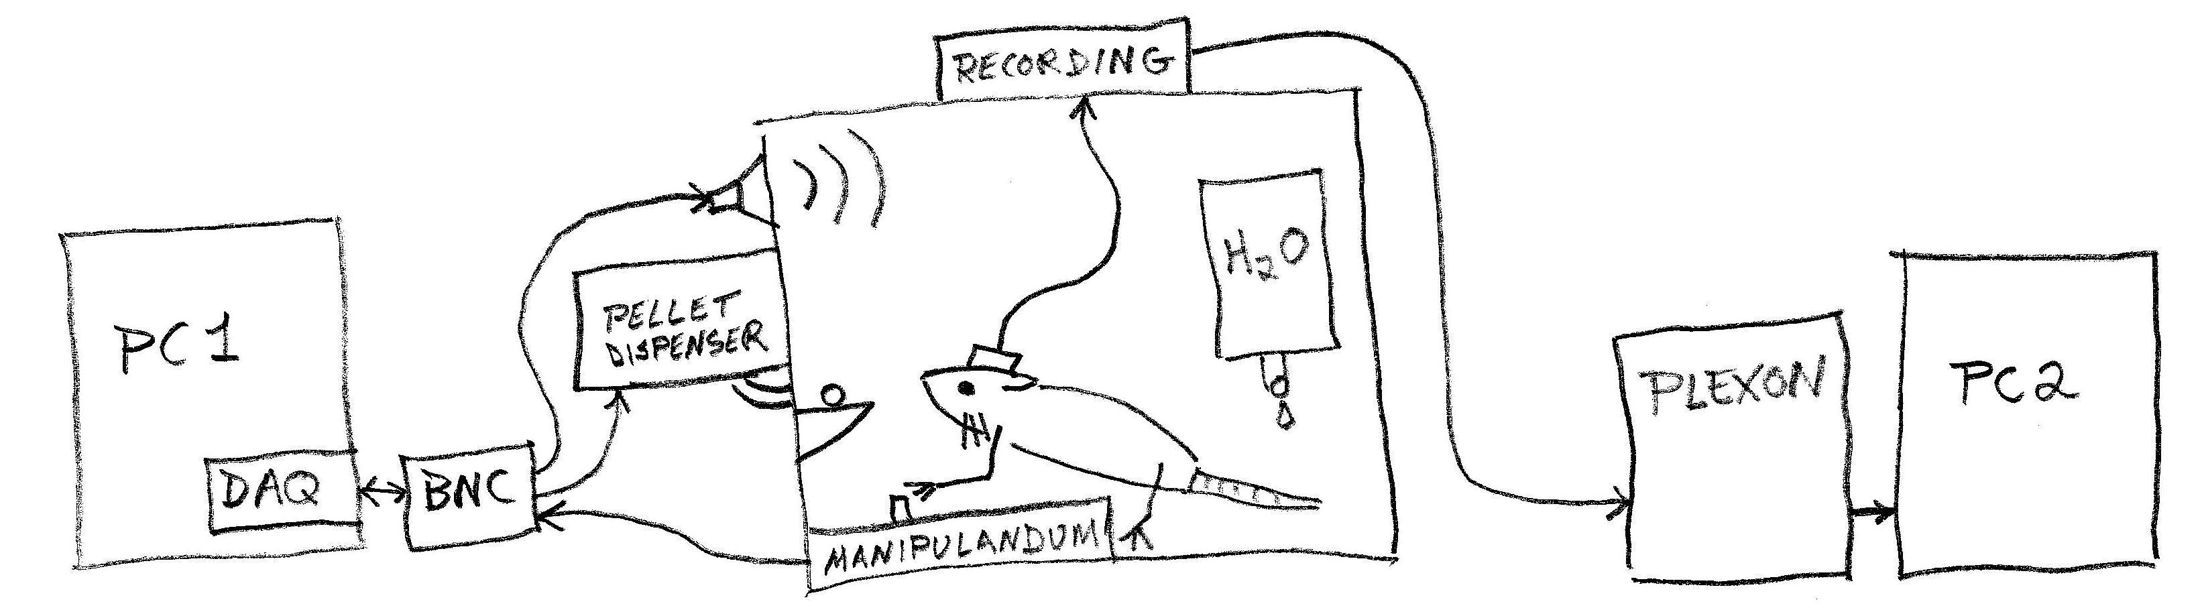
Figure 1. Open-Loop Neural Recording

As a member of the Laboratory for Cortical Neurointeractivity, the student is interested in the long-term objective of pursuing an experiment in the real-time control of an audio speaker using simultaneously recorded neurons in the motor cortex (Fig. 1). This experiment will be novel in that it will be the first of its type to use auditory feedback. Understanding, implementing, and comparing the correlation algorithms used in previous brain-control interface (BCI) research is proposed as a first year research project as it serves as an initial step toward the auditory control experiment. The secondary objective of the proposed research project is to develop software implementations of the algorithms that meet the requirements for use in the auditory control experiment.

Methods
At a minimum, the algorithms to be investigated will include population vector encoding, perceptron learning, and independent component analysis (ICA). The student will compare and report on the accuracy of the algorithms. The student will verify that the software implementations of the algorithms are suitable for real-time control experiments.

Population Vector Encoding
Population vector encoding is the technique first used by Georgopoulus, et al. [Krakauer 2000]. The research advisor has provided the student with examples of the algorithm as implemented in a spreadsheet. The student will translate the code into a real-time programming language.

Perceptron Learning
The firing frequencies of the individual neurons will be measured and correlated with the direction of movement. In an offline analysis, a simple artificial neural network (ANN), a single-layer perceptron [Hertz 1991], will be trained to correlate the direction of movement with the current firing frequencies of the recorded neurons. Except for a non-linearity in the final stage of processing, using a single-layer perceptron is roughly equivalent to a mathematical operation variously described as the dot product, inner product, projection, or vector angle cosine [Taylor 2002].

The input to the perceptron will be the firing frequencies of the neurons as converted to z-scores [Triola 1998] where the means will be set to the baseline firing frequency of each neuron. After successful offline training of the perceptron, the synaptic weights will be fixed.

Independent Component Analysis
The student will investigate the applicability of a relatively new mathematical technique known as independent component analysis (ICA) [Hyvarinen 2001, Stone 2004]. ICA is used to separate a signal into its individual components and been applied previously within the field of neuroscience. The student will learn the mathematical theory behind ICA and, if appropriate, provide an implementation for comparison.

Algorithm Comparison
The student will compare the accuracy of the algorithms in determining the direction of movement from the simulated spiking activity. Accuracy will be quantified using one or more statistical techniques. To ensure that the implementations are performing better than chance, the comparison will include a control implementation that randomly selects, independent of the spiking activity, directions of movement with a probability distribution matching the training data.
The training data will be randomly generated based on an algorithm provided by the research advisor. To prevent the results from being skewed by a limited training set, new data will be generated each time it is used for either training or evaluation.

Real-time Implementation
The earliest experiments in this area of research used offline batch processing. The student will ensure that the software algorithms implemented in this project can determine the intended direction of movement from the spiking activity in real-time. For this purpose, real-time will be defined as a processing lag of less than 100 to 300 milliseconds, depending on the estimated requirements for the subsequent brain control experiment.

Bibliography
- [Cauller 1995] Cauller, Larry, “Layer I of primary sensory neocortex: where top-down converges upon bottom-up”, Behavioural Brain Research 71 (1995) 163-170.
- [Chapin 1999] Chapin, et al., “Real-time control of a robot arm using simultaneously recorded neurons in the motor cortex”, Nature Neuroscience, volume 2 no. 7, 1999 July.
- [Duncan 2004] Duncan Graham-Rowe, “Brain implants 'read' monkey minds”, NewScientist.com, 2004 July 08, http://www.newscientist.com/news/news.jsp?id=ns99996127, viewed 2004-07-16.
- [Hertz 1991] Hertz, et al., Introduction to the Theory of Neural Computation, Addison Wesley, 1991.
- [Hyvarinen 2001] Hyvarinen, et al., Independent Component Analysis, John Wiley & Sons, New York, 2001.
- [Johnson 2003] R. Colin Johnson, “EEG brain cap detects musical creativity”, EE Times, 2003 October 22, http://www.eetimes.com/at/news/OEG20031022S0047, viewed 2004-07-07.
- [Kennedy 2004] Kennedy, et al., “Using human extra-cortical local field potentials to control a switch”, J. Neural Eng. 1 (2004) 72–77.
- [Krakauer 2000] Krakauer, John and Claude Ghez, “Direction of Movement is Encoded by Populations of Cortical Neurons”, In: Principles of Neural Science, 4th Ed., 2000, Kandel et al. (Ed.), Ch. 38, pp765-769.
- [Leuthardt 2004] Leuthardt, et al., “A brain–computer interface using electrocorticographic signals in humans”, J. Neural Eng. 1 (2004) 63–71.
- [Lusted 1996] Lusted, et al., “Controlling Computers with Neural Signals”, Scientific American, 1996 October.
- [Mel 1996] Mel, B.W., Niebur, E., & Croft, D.W., "How neurons may respond to temporal structure in their inputs." Proceedings of CNS*96, Computational Neuroscience Meeting, Boston, MA, 1996.
- [Miranda 2003] E. R. Miranda, K. C. Sharman, K. Kilborn, and A. Duncan. On Harnessing the Electroencephalogram for the Musical Braincap. Computer Music Journal, 27:80-102, Summer 2003.
- [Musallam 2004] Musallam, et al., “Cognitive Control Signals for Neural Prosthetics”, Science, 2004 July 09, Vol. 305, p258.
- [Schwartz 2004] Andrew B. Schwartz, “Cortical Neural Prosthetics”, Annu. Rev. Neurosci. 2004. 27:487–507.
- [Serruya 2002] Serruya, et al., “Instant neural control of a movement signal”, Nature, Vol. 416, 2002 March 14, p141.
- [Stone 2004] Stone, James V., Independent Component Analysis: A Tutorial Introduction, MIT Press, 2004.
- [Takahashi 2003] Takahashi, “Automatic Sorting for Multi-Neuronal Activity Recorded With Tetrodes in the Presence of Overlapping Spikes”, J Neurophysiol 89: 2245–2258, 2003.
- [Taylor 2002] Taylor, et al., “Direct Cortical Control of 3D Neuroprosthetic Devices”, Science 296, 1829 (2002).
- [Taylor 2003] Taylor, et al., “Information Conveyed Through Brain-Control: Cursor Versus Robot”, IEEE Transactions on Neural Systems and Rehabilitation Engineering, Vol. 11, No. 2, 2003 June.
- [Tillery 2003] Tillery, et al., “The general utility of a neuroprosthetic device under direct cortical control”, Proceedings of the Engineering in Medicine and Biology Society 25th International Conference, 2043-2046, 2003.
- [Triola 1998] Triola, Mario F., Elementary Statistics, 7th Ed., p92, Addison Wesley Longman, 1998.

